|  |  |
| --- | --- |
| Dreams and Dances concert**Conducted by – Richard McIntyre OAM, BMus (University of Sydney)** |  |
| Richard McIntyrePhoto by Chrissy Maguire   Richard has maintained a long and distinguished career as bassoonist, music educator, conductor and arranger. A Composition graduate from Sydney University, he was appointed Associate Principal Bassoon with the Sydney Symphony Orchestra as a 20-year-old in 1968, moving to The Canberra School of Music as a foundation member of the Canberra Wind Soloists in 1978. With this renowned quintet, he recorded and toured internationally during a 30-year period, and gave it a unique repertoire with his virtuoso arrangements of large-scale orchestral works. He was for many years Principal Bassoon with the Australian Chamber Orchestra, and appeared on many occasions as guest Principal Bassoon with most of the Symphony Australia Orchestras - also as concerto soloist, and independently as a recitalist. His continuing work as Principal Bassoon with the Canberra Symphony Orchestra dates back to student days of 1965 - 67. If you'd like to hear some of his work as bassoonist, chamber musician, and arranger, you'll find it on YouTube under Canberra Wind Soloists.   Simultaneously, he has sustained a career as one of Australia's most respected bassoon teachers, at all levels from beginner to post-graduate and professional. In addition he has worked tirelessly in the development of orchestral and ensemble skills with students of all instruments, particularly at the advanced tertiary level. He was for many years a regular tutor and conductor at the Australian Youth Orchestra's National Music Camps. He has taught over many years in south-east Asia.   His work as a conductor is well-known, particularly in Canberra. He was Conductor and Musical Director of the Canberra Youth Orchestra from 1980 - 1990, greatly broadening its repertoire and general endeavour, and led it on three highly-successful and widely-acclaimed European tours. His Canberra contribution has included development of and much work with the School of Music Orchestra, Canberra Opera, Canberra Philharmonic Society, thirteen-years as Musical Director of The Llewellyn Choir (with development of its accompanying professional ensemble, The Canberra Chamber Orchestra), and three years as Musical Director of The Oriana Chorale.   His numerous conducting activities outside of Canberra have included the foundation and development of the Barrier Reef Orchestra, with which he continues his association as Artistic Advisor and frequent conductor.   His 35-year career at the Canberra (now ANU) School of Music played a significant part in the creation of its erstwhile international reputation. Awards have included 1986 Canberran of the Year, Advance Australia, Sounds Australian, and National Critics' Circle awards. In 1992 he was granted an Order of Australia Medal, for services to Music and Music Education, particularly for his work with the Canberra Youth Orchestra. In 2013, he was elected President of the Australian Double Reed Society. |  |

|  |  |
| --- | --- |
| Ticketshop link | 7:30 pm Tuesday 8 March at Townsville CivicTheatre  $38 Adult - $34 Concession - Child/student $15  NQE Member - $32 |
| Cards accepted as concession price tickets - Pension, Tertiary Students Full-time and Senior cards. | |

**Conductor: Mark Shiell**  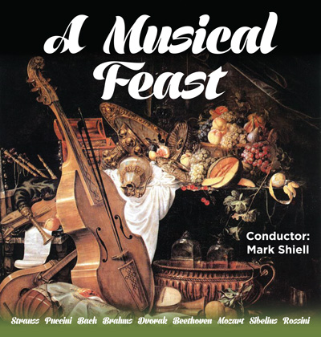

The Barrier Reef Orchestra’s final concert for 2015 is A Musical Feast.   
  
The conductor is Mark Shiell making a return visit to Townsville.   
  
The concert will include music from many different composers including Bach, Brahms and Strauss and will feature soprano, Julie O’Connor who will sing numbers from Puccini and Dvorak. 

|  |
| --- |
| Mark Shiell Mark has guest-conducted ensembles including the Melbourne Symphony Orchestra, West Australian Symphony, Moscow Symphony Orchestra, State Academic Symphony Orchestra of St. Petersburg, Victorian Opera, Orchestra Ensemble Kanazawa, Canberra Symphony Orchestra, Sydney Sinfonia, Melbourne Youth Orchestra, University of Melbourne Symphony Orchestra and the Orchestras of the State Music Camps in Melbourne and Adelaide.  Currently he serves as Artistic Director and Principal Conductor of Zelman Symphony Orchestra, the Ballarat Symphony and the Macquarie Philharmonia.  His love of community and youth music has kept him busy contributing to the growth and development of important initiatives in both of these areas here in Australia. Most recently, Mark developed a Regional Orchestra Weekend for ensembles from across Victoria to meet and perform together, with the aim to make this an annual event.  Mark is also passionate about the education and training of future conductors, and has been frequently involved as a guest teacher of the Masters of Conducting students at the Melbourne Conservatorium in 2015. |

|  |  |
| --- | --- |
| Ticketshop link | 7:30 pm Saturday 7 November at Townsville CivicTheatre $38 Adult - $34 Concession - Child/student $15  NQE Member - $32 |
| Cards accepted as concession price tickets - Pension, Tertiary Students Full-time and Senior cards. | |

**REVIEW**   
A Musical Feast   
by LGM   
  
A musical feast was somewhat of a fabulous dinner dance with four lively dances of the Slavonic and Hungarian kind included.   
  
The opening Slavonic Dances Numbers 1 and 8 by Anton Dvorak were an indication of the feast to follow. The rhythm and exuberance was conveyed so well we didn’t need to actually see the dancers performing those tricky steps. Brahms Hungarian dances which lead the second part of the program were similarly very lively and invigorating; Brahms used folk songs extensively in these pieces and while being no expert I felt quite a bit of gypsy music infiltrated them.   
  
N.S.W Soprano, Julie O’Connor sang four of the most beautiful songs in the repertoire. Her voice was pure and very versatile in the range of notes required. She also had the best facial and hand gestures I have seen which really enhances the enjoyment of the music. Many singers, whilst having a great voice, tend to be wooden in gesture and stance. The Orchestra was very much part of the song, never intruding but always asserting its contribution to the overall beauty of the music.   
  
In this 150 anniversary year of Sibelius Finlandia was a joy to hear again. This became Finland’s unofficial anthem during the independence war against Russia (played under a variety of names so as to not to antagonise the aggressors) in the 1890’s and is very stirring   
  
My friend commented that “The BRO’s interpretation under Mark Shiell's baton was crisp, and the move from the dark, atmospheric mood to the lighter song or hymn seemed startling, this was done so beautifully and effortlessly. As a non musician, I loved it.”   
  
A musical feast without Beethoven and Bach would be like food without salt. We were privileged to hear Bach’s Double Violin Concerto’s 1st movement with two of the many talented young players from the orchestra, Julia Ramsbotham and Florence Cappler-Shillington, masterfully playing the double solo and the orchestra’s string section ably accompanying them. Beethoven’s 5th Symphony’s first movement was slightly different as Conductor Mark Shiell’s research showed that Ludwig Van originally meant it to be at a different tempo to what we are now accustomed to hear. The Orchestra certainly showed how right he was, every note could be heard and every note added up to a most beautiful piece of music which was over too soon.   
  
For me the piece de resistance of the concert was Rossini’s William Tell Overture, the first part with the cellos and double basses was sublime then I found I just didn’t want the storm to finish but when the Trumpets heralded the more familiar part I was carried along with the galloping music – it was great music played very well.   
  
For that little bit of extra chocolate we were treated to a repeat of the Hungarian Dance No 5.   
  
So Bravo Mark, Bravo Musicians, Bravo everyone who contributed - as I say after almost every concert – This has been the best concert yet.

**­­**

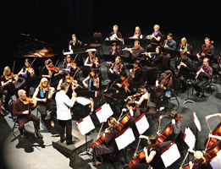**World Music Concert**  
As you travel the globe one of the standout features of so many different countries is undoubtedly their music. This concert saves on the shoe leather and brings an eclectic mix of music from all over the world to Townsville. A unique performance conceptualised and developed here in Townsville by the Barrier Reef Orchestra highlighting the stunning diversity of cultural music from around the globe. Featuring the Orchestra and several international artists performing music from Asia, the Americas, the British Isles, Europe and of course Australia. So pack away the passport take the trip of a life time and never leave home. Join Townsville’s very own Barrier Reef Orchestra in their 15th year for a World Music Concert. 

|  |  |  |
| --- | --- | --- |
| **Special Guests -** | |  |
| |  |  | | --- | --- | | Adam Lopez | Adam Lopez – Developed his multi-octave voice while studying opera in Australia | | Domenico Taraborrelli | Domenico Taraborrelli – one of Brisbane’s most experienced and versatile multicultural entertainers | | Adam Lopez | David Hudson – musician, entertainer, artist and actor | |
|  |

|  |  |
| --- | --- |
| Ticketshop link | 8 pm Saturday 5 September at Townsville CivicTheatre  $47 Adult - $42 Concession - Child/student $25  Group 10+ $42 per ticket |
| Cards accepted as concession price tickets - Pension, Tertiary Students Full-time and Senior cards. | |

**REVIEW**   
World Music Concert   
by Helen Land   
  
The World Music Concert was a breath of fresh air to Townsville music lovers who had just about reached classical music saturation following AFCM.   
  
Andrew Ryder poured his expertise and enthusiasm into this opportunity provided through Townsville City Council sponsorship. Andrew developed the concept for the concert; sourced the music which involved him personally arranging some of the music; liaising with the professional performers; and rehearsing and conducting the Barrier Reef Orchestra.   
  
The performance delighted more than one sense through the visual backdrop showing scenery pertinent to the music and the amazing musical sound evoking toe tapping, clapping, singing and sheer enjoyment.   
  
The world tour began with David Hudson on didgeridoo, guitar and vocals synchronizing with the visual backdrop to grab the audiences’ attention, performing the popular John Williamson ballad Raining on the Rock. The tour continued through Korea and Cuba courtesy of a quality Barrier Reef Orchestral performance. Next, virtuosic Domenico Taraborrelli on piano accordion and vocalist Adam Lopez, supported by the Orchestra, engaged the audience with Latin American pieces. Unfortunately the balance was a little off, with the soloists being much louder.   
  
The second half began with the Barrier Reef Orchestra creating an American theme through Aaron Copland before heading off to Europe with the Orchestra supporting Domenico once again in Italy, John Ferguson on bagpipes with vocalist Cynthia Clark in Scotland and Adam Lopez in Spain.   
  
The tour aptly returned to Australia with all the soloists returning to the stage to present a rousing and emotive performance of I am Australian.   
  
This very enjoyable performance once again demonstrated the talented people choosing to live in Townsville and able to produce such a high class production, equal to anywhere. This was reinforced by the willingness of quality professional musicians to come to Townsville and perform with the Barrier Reef Orchestra. I feel certain if more was known about the concert the Civic Theatre would easily have been at capacity.

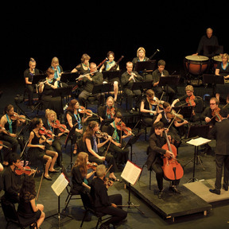 **SUNDAY August 2nd   
25th Anniversary Celebration Concert – The 1812!   
Queen's Gardens, 3:00 PM**  
Presented by Townsville City Council and AFCM   
Free Public Event   
Hosted by Damien Beaumont ABC Classic FM   
  
  
**Copland***Fanfare for the Common Man*   
Conducted by Andrew Ryder   
Barrier Reef Orchestra, 1RAR Band, Ben Jacks   
  
**Walton***Crown Imperial*   
Conducted by Andrew Ryder   
Barrier Reef Orchestra   
  
**Grieg***Prelude from Holberg Suite*   
Camerata of St John's   
  
**Jerome Kern***Smoke Gets in your Eyes*   
Amy Dickson, Camerata of St John’s   
  
**Leroy Anderson***Plink, Plank, Plunk*   
Camerata of St John's   
  
**Henry Mancini***Moon River*   
Amy Dickson, Camerata of St John's   
  
**Trad (Roumanian) arr. Michael Patterson***Breaza (a la camerata)*   
Camerata of St John's   
  
**Jack Pettis/Billy Meyers/Elmer Schoebel***Bugle Call Rag*   
**María Grever/Stanley Adams***What A Difference A Day Makes*   
**Peggy Lee/Bill Schluger***I Love Being Here With You*   
**Joe Garland/Andy Razaf arr. Glenn Miller***In The Mood*   
Conducted by Major Lindsay Mee   
1RAR Band   
  
**Giacomo PUCCINI (1858-1924)***Gianni Schicchi: O mio babbino caro*   
  
**Antonín DVOŘÁK (1841-1904)***Rusalka: Song to the Moon*   
Conducted by Andrew Ryder   
Cheryl Barker, Barrier Reef Orchestra   
  
**Tchaikovsky***1812 Overture Op.49*   
Audience participation instead of cannon fire!   
Conducted by Andrew Ryder   
Barrier Reef Orchestra, 1RAR Band

**REVIEW**   
AFCM 25th Anniversary Celebration Concert   
by Helen Land

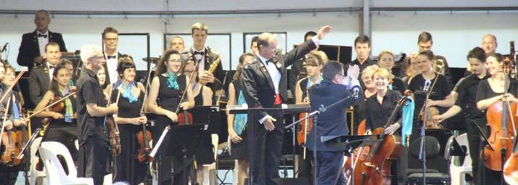   
  
A very pleasant Sunday afternoon in Queens Gardens was attended by approximately three and half thousand satisfied music lovers. This free concert organised to celebrate the 25th Anniversary of the AFCM was also a fitting opportunity for BRO to celebrate its 15th Anniversary with it’s first ever outdoor public performance.   
  
The tastes of all music lovers was satiated. The concert opened with the ceremonial and pompous Brass composition by Aaron Copland titled Fanfare for the Common Man, followed by the equally ceremonial Imperial March by William Walton. Genuine fun and musical camaraderie emanated from the performance by Camerata of St Johns with their virtuosic classical performance. In addition they ably accompanied Amy Dickson in her flawless saxophone performance with her distinctive tone clearly displaying the reason she is sought after around the world.   
  
1RAR Big Band played to the high standard Townsville audiences are familiar. They had the audience tapping their feet to their musical and vocal compositions. Cheryl Barker’s powerful soprano rang across the park and most likely was heard on Castle Hill as she sang two arias accompanied by BRO and conducted by UK conductor Nicholas Daniel.   
  
The finale of the afternoon which included musicians from all three ensembles was the 1812 Overture. It was delightful to see the audience enthusiastically participate in this finale. This pleasant afternoon can only be rated as a huge success and may prove to be the first of many performances in years to come.   
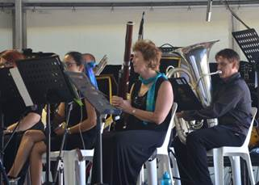  
  
  
  
Helen performing with the BRO in Queens Gardens

|  |  |
| --- | --- |
| Orchestra image | Conductor – **Raymond Yong**  Flute – **Jennifer Bradstreet** (2014 ACVC winner)  Harp – **Leah Li**  featuring -   Tchaikovsky: Waltz of the Flowers from Nutcracker  Chaminade Concertino  Mozart: Flute and Harp Concerto -Andantino (2nd Movt)  Bizet: L'arlesienne Suites (excerpts)  Suite 1: Prelude, Menuet  Tchaikovsky Symphony no 2 "Little Russia" |
|  |

|  |  |  |  |  |
| --- | --- | --- | --- | --- |
| **Last Night at the Proms** | | **Last Night at the Proms**  Featuring **The Company Singers**  Arranged and Conducted by **Richard McIntyre**  **Saturday, 1st November 2014** at Townsville Civic Theatre | | |
|  |  | | |  |
|  | **Masterworks Tchaikosvky: Symphony No. 5**  **Grieg Piano Concerto**  Conductor – **Mark Shiell**  Soloist – **Stefan Cassomenos**  (2013 ACVC runner-up)  Concert Partner – **Australian Concerto and Vocal Competition**  **Saturday, 6th September, 7:30pm Townsvillle Civic Theatre**  **Sunday, 7th September, 2:00pm Burdekin Theatre, Ayr** | | Stefan Cassomenos | |

|  |  |  |
| --- | --- | --- |
| Peter&Wolf | **Children’s Concert**  Featuring  **Peter and the Wolf**  And  **Music from Harry Potter**  **Saturday, 15th June 1pm and 3pm Riverway Arts Centre** | Harry Potter |